EXPERIMENT 4: Task Analysis and User Flow Documentation of an Online Shopping Application using Lucidchart

NAME: VASANTH B REG NO: 240701820

AIM:
To understand and document the steps a user takes to complete the main tasks within an online shopping application and to design corresponding user flows and wireframes using Lucidchart.

PROCEDURE:

Step 1: Assigning Tasks
The following main tasks of the online shopping app were identified:
- Browsing Products

- Searching for a Specific Product

- Adding a Product to the Cart

- Checking Out

- Tracking Orders

Step 2: Task Analysis and User Flow Documentation

1. Browsing Products
Task Analysis:
- User opens the app.

- User lands on the Home Screen.

- User selects a product category.

- User views the product list.

- User selects a product.

- User views product details.

User Flow:
Home Screen → Product Categories → Product List → Product Details

2. Searching for a Specific Product
Task Analysis:
- User taps the search bar.

- User enters product name or keyword.

- Search results are displayed.

- User selects a product.

- User views product details.

User Flow:
Search → Enter Query → Search Results → Product Details

3. Adding a Product to the Cart
Task Analysis:
- User browses or searches for a product.

- User views product details.

- User selects size, color, or quantity.

- User clicks “Add to Cart”.

- Cart is updated.

User Flow:
Product Details → Select Options → Add to Cart → Cart Updated

4. Checking Out
Task Analysis:
- User opens the cart.

- User reviews cart items.

- User proceeds to checkout.

- User enters shipping information.

- User enters payment details.

- User confirms payment.

- Order is placed successfully.

User Flow:
Open Cart → Review Cart → Proceed to Checkout → Enter Shipping Info → Enter Payment
Info → Confirm Payment → Place Order → Order Confirmation

5. Order Tracking
Task Analysis:
- User navigates to “My Orders”.

- User selects an order.

- User views tracking details and delivery status.

User Flow:
My Orders → Select Order → View Tracking Details
Step 3: Creating User Flow Diagram in Lucidchart
- Created a new blank document in Lucidchart.

- Enabled Flowchart shapes.

- Used:

  - Oval for Start/End

○ Rectangle for Processes

○ Diamond for Decision points

- Connected shapes using directional arrows.

- Included decision points such as:

  - Is User Logged In?

○ Confirm Payment?

- Arranged the flow logically from login to order confirmation.

Step 4: Creating Wireframes in Lucidchart
Low-fidelity wireframes were created for the following screens:
- Home Screen

- Product Category Page

- Product List Page

- Product Details Page

- Cart Page

- Checkout Page

Each wireframe included:
- Navigation bar

- Content layout

- Buttons

- Input fields

- Product details

- Checkout form

The wireframes visually represent how users interact with each screen.
Output:
Flowchart:
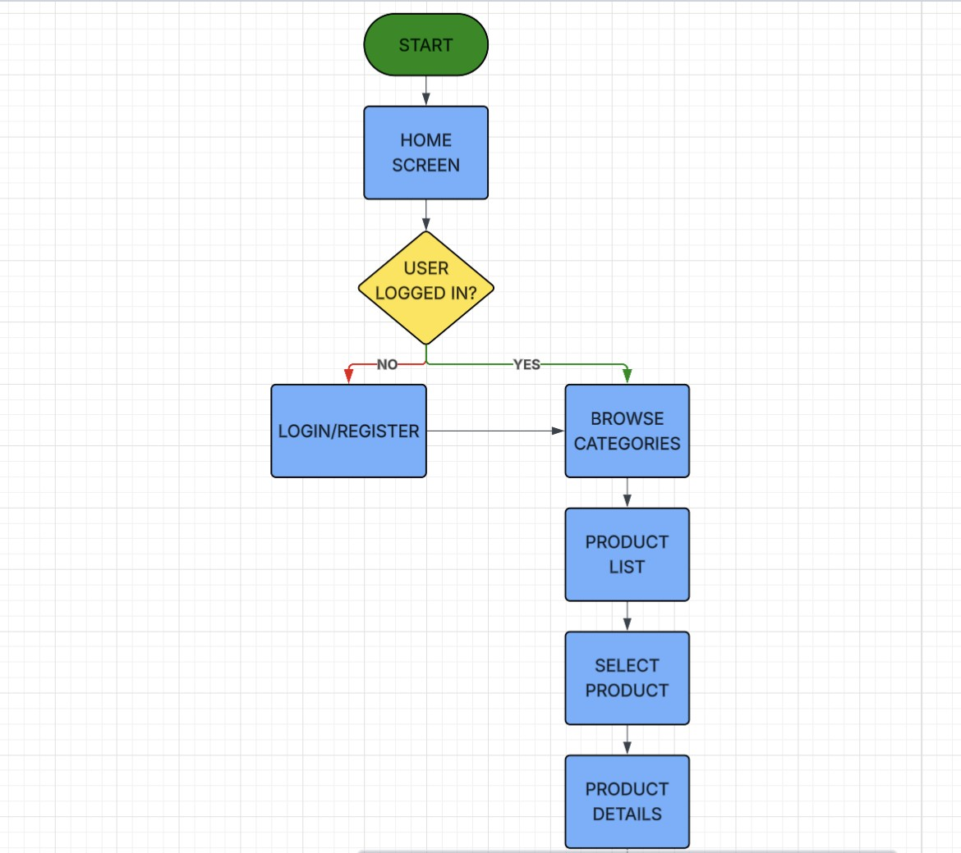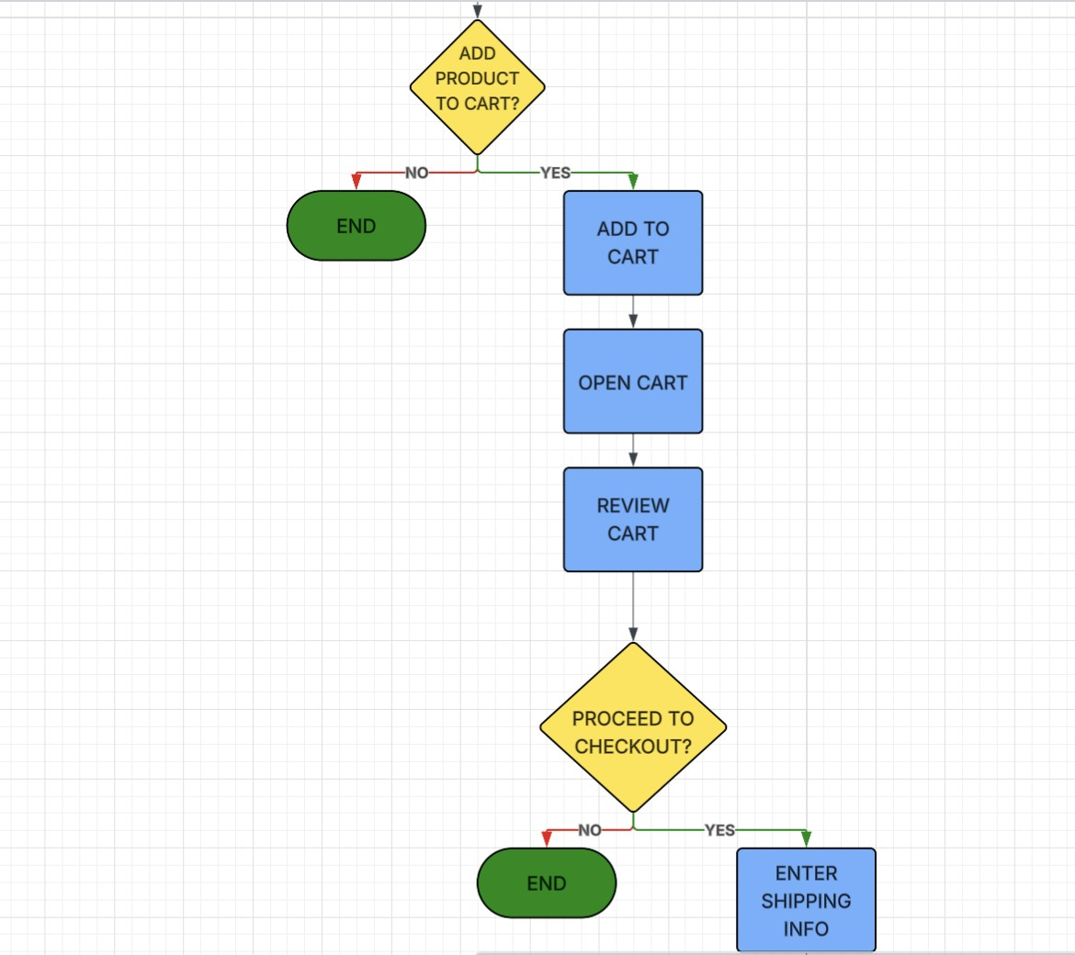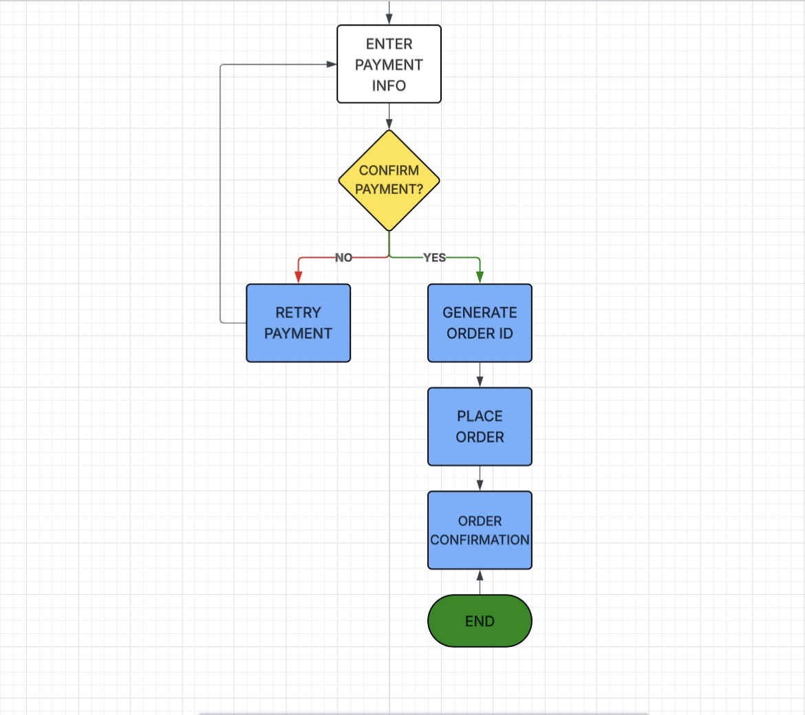

Wireframing:

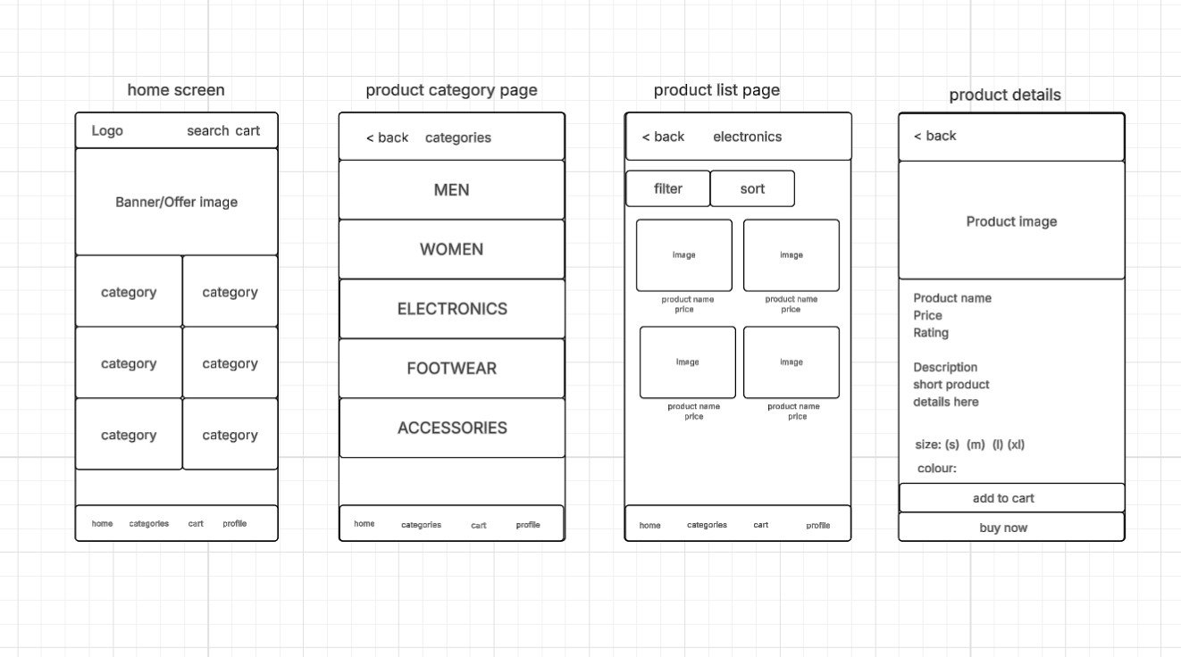
Prototype links:
https://lucid.app/lucidchart/baaa7a56-fed0-4d43-b2d7-f522a77e472a/edit?invitationId=inv_72f79 394-b6cb-4183-b549-5b3c384c711e&page=0_0#

RESULT:
The task analysis successfully identified the primary user actions within an online shopping application. User flows were documented clearly, and corresponding flowcharts were created using Lucidchart. Wireframes were designed to visually represent the app interface and user interaction process.

